LESSON 15.
Microbiology diagnosis of acute respiratory viral infections (families of Adenoviridae and Coronaviridae, Rhinovirus genus) and smallpox (Poxviridae family)
LESSON PLAN:
• Adenoviridae family, classification. Virion structure, cultivation, serotypes, pathogenicity characteristics. Persistence. Microbiological diagnosis.
• Coronaviridae family, classification. Virion structure, serotypes, cultivation problems, pathogenicity characteristics. Severe acute respiratory syndrome (SARS) and COVID-19 infection, microbiological diagnosis, specific prevention problems.
• Genus Rhinovirus. Role in human pathology.
• Poxviridae family, classification. Virion structure, cultivation, persistence. Monkeypox virus. Pathogenicity characteristics. Microbiological diagnosis, specific prevention.

ADENOVIRUSES
Trigger Words
Pharyngitis, conjunctivitis, atypical pneumonia, icosadeltahedral capsid

Biology, Virulence, and Disease
ᑏ Medium-sized icosadeltahedral capsid with fibers, linear DNA genome with terminal proteins
ᑏᑏ E1A and E1B proteins inactivate E6 and E7 to promote growth
ᑏᑏ Virus encodes polymerase
ᑏᑏ Capsid virus resistant to inactivation
ᑏᑏ Lytic virus
ᑏᑏ Causes pharyngitis, conjunctivitis, atypical pneumonia, infantile gastroenteritis, acute respiratory disease
ᑏᑏ Can be used as vector for making vaccines and gene therapy

Epidemiology
ᑏᑏ Transmitted by aerosols, direct contact, fecal-oral, contaminated swimming pools

Diagnosis
ᑏᑏ Immunological assays and PCR genome analysis

Treatment, Prevention, and Control
ᑏᑏ Adenovirus types 4 and 7 vaccine only for military

Illnesses Associated with Adenoviruses
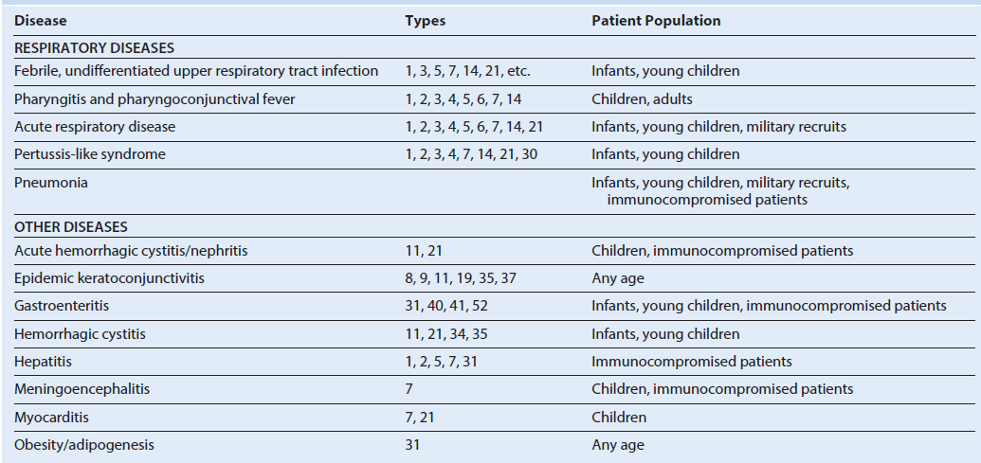

Unique Features of Adenovirus
Naked icosadeltahedral capsid has fibers (viral attachment proteins) at vertices.
Linear double-stranded genome has 5′ terminal proteins.
Synthesis of viral DNA polymerase activates a switch from early to late genes.
Virus encodes its own DNA polymerase and other proteins to facilitate growth and immune escape.
Human adenoviruses are grouped A through G by DNA homologies and by serotype (>55 human types).
Serotype is mainly a result of differences in the penton base and fiber protein, which determine the nature of tissue tropism and disease.
Virus causes lytic, persistent, and latent infections in humans, and some strains can immortalize certain animal cells.

Major Adenovirus Proteins
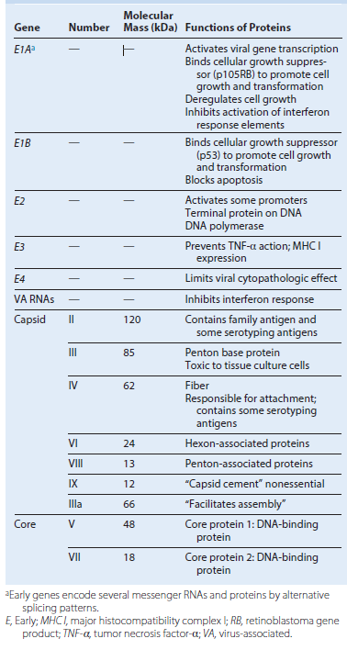

Simplified genome map of adenovirus type 2. Genes are transcribed from both strands (l and r) in opposite directions. The early genes are transcribed from four promoter sequences, and each generates several messenger RNAs by processing the primary RNA transcripts. This produces the full repertoire of viral proteins. The splicing pattern for only the E2 transcript is shown as an example. All of the late genes are transcribed from one promoter sequence. E, Early protein; L, late protein. (Modified from Jawetz, E., Adelberg, E.A., Melnick, J.L., 1987. Review of Medical Microbiology, 17th ed. Appleton & Lange, Norwalk, CT.)

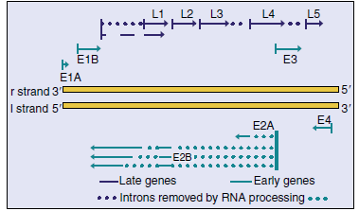

Disease Mechanisms of Adenoviruses
Virus is spread in aerosols, in fecal matter, and by close contact.
Fingers spread virus to eyes.
Virus infects mucoepithelial cells in the respiratory tract, gastrointestinal tract, and conjunctiva or cornea, causing cell damage directly.
Disease is determined by the tissue tropism of the specific group or serotype of the virus strain.
Virus persists in lymphoid tissue (e.g., tonsils, adenoids, Peyer patches).
Antibody is important for prophylaxis and resolution, but cellmediated immunity is also important.

Epidemiology of Adenoviruses
Disease/Viral Factors
Capsid virus is resistant to inactivation by gastrointestinal tract, drying, and detergents.
Disease symptoms may resemble those of other respiratory virus infections.
Virus may cause asymptomatic shedding.
Transmission
Direct contact, respiratory droplets and fecal matter on hands and fomites (e.g., towels, contaminated medical instruments), and
inadequately chlorinated swimming pools and ponds
Who Is at Risk?
Children <14 years of age
People in crowded areas (e.g., day-care centers, military training camps, swimming clubs)
Geography/Season
Virus is found worldwide.
There is no seasonal incidence.
Modes of Control
Live vaccine for serotypes 4 and 7 is available for military use.

Clinical Summaries

Pharyngoconjunctival fever: A 7-year-old student develops sudden onset of red eyes, sore throat, and a fever of 38.9° C (102° F).
Several children in the local elementary school have similar symptoms.

Gastroenteritis: An infant has diarrhea and is vomiting. Adenovirus serotype 41 is identified by polymerase chain reaction
analysis of stool for epidemiologic reasons.

Time course of adenovirus respiratory infection.
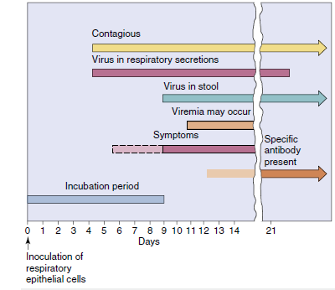

CORONAVIRUSES
Trigger Words
Common cold, SARS, MERS

Biology, Virulence, and Disease
ᑏ Medium size, enveloped, (+) RNA genome
ᑏᑏ Detergent resistant because of glycoprotein corona (exception to the rule for enveloped viruses)
ᑏᑏ Encodes RNA-dependent RNA polymerase, replicates in cytoplasm
ᑏᑏ Most coronaviruses cannot replicate at body temperature, restricted to upper respiratory tract
ᑏᑏ Most coronaviruses cause the common cold
ᑏᑏ MERS and SARS can replicate at 37° C and cause severe pneumonias

Epidemiology
ᑏᑏ Transmitted by aerosols, direct contact, fecal oral, contaminated swimming pools

Diagnosis
ᑏᑏ Symptomatology, RT-PCR genome analysis, or respiratory secretions

Treatment, Prevention, and Control
ᑏᑏ Quarantine for SARS, MERS

Model of a coronavirus. The viral nucleocapsid is a long, flexible helix composed of the positive-strand genomic RNA and many molecules of the phosphorylated nucleocapsid protein N. The viral envelope consists of a lipid bilayer derived from the intracellular membranes of the host cell, two or three viral glycoproteins (Spike [S], E, possibly hemagglutinin-esterase [HE]), and a matrix protein. (A, Courtesy Centers for Disease Control and Prevention, Atlanta, Georgia. B, Modified from Fields, B.F., Knipe, D.M., 1985. Virology. Raven, New York, NY.
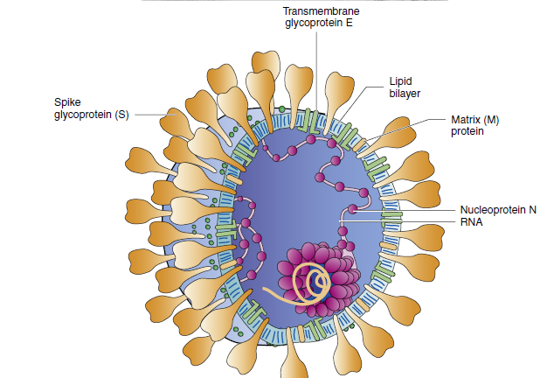

Unique Features of Coronaviruses
Virus has medium-sized virions with a solar corona–like appearance.
Single-stranded, positive-sense RNA genome is enclosed in an envelope containing the E2 viral attachment protein, E1 matrix
protein, and N nucleocapsid protein.
Translation of genome occurs in two phases: (1) the early phase produces an RNA polymerase (L), and (2) the late phase, from a
negative-sense RNA template, yields structural and nonstructural proteins.
Virus assembles at the rough endoplasmic reticulum.
Virus is difficult to isolate and grow in routine cell culture.

Major Human Coronavirus Proteins
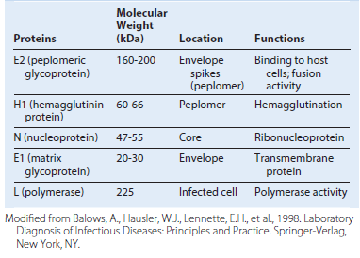

Replication of human coronaviruses. The E2 glycoprotein interacts with receptors on epithelial cells, the virus fuses or is endocytosed into the cell, and the genome is released into the cytoplasm. Protein synthesis is divided into early and late phases, similar to that in the togaviruses. The genome binds to ribosomes, and an RNA-dependent RNA polymerase is translated. This enzyme generates a full-length, negative-sense RNA template for the production of new virion genomes and six individual mRNAs for the other coronavirus proteins. The genome associates with rough endoplasmic reticulum membranes modified by virion proteins and buds into the lumen of the rough endoplasmic reticulum. Vesicles that contain the virus migrate to the cell membrane, and the virus is released by exocytosis. (Modified from Balows, A., Hausler, W.J., Lennette, E.H., et al., 1988. Laboratory Diagnosis of Infectious Diseases: Principles and Practice. Springer-Verlag, New York, NY.)
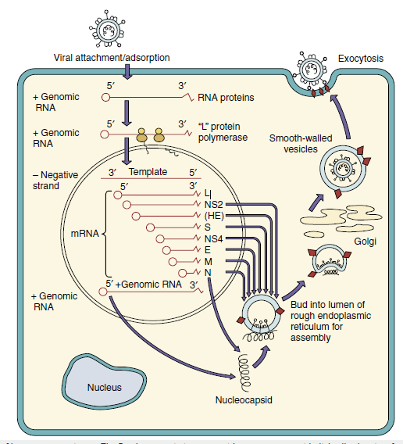

Disease Mechanisms of Human Coronaviruses
Human coronavirus infects and kills epithelial cells of the upper respiratory tract.
Virus replicates best at 33° C to 35° C; therefore it prefers the upper respiratory tract.
Reinfection occurs in the presence of serum antibodies.
The glycoprotein “corona” helps this enveloped virus survive the gastrointestinal tract.
SARS-CoV and MERS-CoV replicate at 37° C, kill cells and initiate inflammatory responses in the lung.

Coronaviruses
Common cold: A 25-year-old office worker develops a runny nose, mild cough, malaise, and a low-grade fever. A coworker has had similar symptoms for the past few days.

SARS: A 45-year-old businessman returned from a 2-week trip to China. Five days after returning home to the United States, he developed a fever of 101.5° F (38.6° C) and cough. Now he observes that it is harder to catch his breath.

PICORNAVIRUSES
Trigger Words

Polio: flaccid paralysis, major and minor disease, fecal-oral

Coxsackievirus A: vesicular diseases, meningitis; coxsackievirus B (body): pleurodynia, myocarditis

Other echovirus and enteroviruses: like coxsackievirus and hepatitis A virus

Rhinoviruses: common cold, acid labile, does not replicate above 33° C

Biology, Virulence, and Disease
ᑏ Small size, icosahedral capsid, positive RNA genome with terminal protein
ᑏᑏ Genome is sufficient for infection
ᑏᑏ Encodes RNA-dependent RNA polymerase, replicates in cytoplasm

(A)Cryoelectron microscopy computer-generated reconstruction of human rhinovirus 16. (B) Cryoelectron microscopy reconstruction of the interaction of a soluble form of intercellular adhesion molecule-1 (ICAM-1) with human rhinovirus 16. Note: There is one ICAM-1 per capsomere. (C) Structure of the human rhinovirus. (D) Binding of the ICAM-1 molecule within the canyon of the virion triggers the opening of the capsid for release of the genome into the cell. RNA, Ribonucleic acid; VP1, 2, 3, 4, viral protein 1, 2, 3, 4; VPg, viral protein genome-linked. (A and B, Courtesy Tim Baker, Purdue University, West Lafayette, Indiana.)
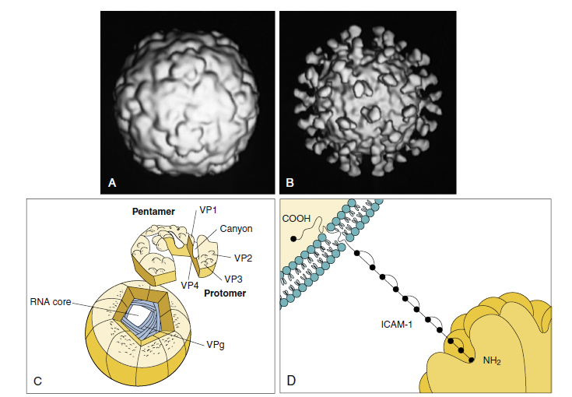

Structure of the picornavirus genome. The genome (7200 to 8400 bases) is translated as a polyprotein that is cleaved by viral-encoded proteases into individual proteins. Viral genes: VP1, 2, 3, 4, capsid proteins 1, 2, 3, 4; 2A cleaves eIF4g to inhibit host protein synthesis; 2B, 2C, 3A, 3B generate membrane-binding, vesicle-forming proteins that facilitate replication; 3B also encodes VPg genome-binding protein; 3Cpro, protease; RdRp, RNA-dependent RNA polymerase. (Redrawn from Whitton, J.L., Cornell, C.T., Feuer, R., 2005. Host and virus determinants of picornavirus pathogenesis and tropism. Nat. Rev. Microbiol. 3, 765–776.)
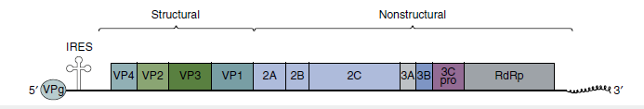

Epidemiology of Rhinovirus Infections

Disease/Viral Factors
Virion is resistant to drying and detergents
Multiple serotypes preclude prior immunity
Replication occurs at optimum temperature of 33° C and cooler temperatures
Transmission
Direct contact via infected hands and fomites
Inhalation of infectious droplets
Who Is at Risk?
Persons of all ages
Geography/Season
Virus found worldwide
Disease more common in early autumn and late spring
Modes of Control
Washing hands and disinfecting contaminated objects help prevent spread
Rhinovirus
Common cold: A 25-year-old office worker develops a runny nose, mild cough, and malaise with a low-grade fever. A coworker has had similar symptoms for the past few days.
Diagnosis
ᑏᑏ Immune assays (ELISA) or RT-PCR
genome analysis of blood, CSF, or other
relevant sample

POXVIRUSES

Trigger Words
Molluscum, smallpox, zoonosis, vaccinia vaccine, cytoplasmic replication

Biology, Virulence, and Disease
ᑏ Very large, enveloped with complex morphology, linear DNA genome fused at ends, virus encodes DNAdependent RNA and DNA-dependent DNA polymerases
ᑏᑏ Cell-mediated immunity essential for control
ᑏᑏ Molluscum contagiosum stimulates cell growth to cause wartlike growth; only infects humans
ᑏᑏ Smallpox: lytic, only infects humans, vesicles appear all at once, bioterror agent
ᑏᑏVaccinia, orf: lytic viruses, zoonotic

Epidemiology
ᑏᑏ Smallpox transmitted by aerosols, direct contact; all others only by contact

Diagnosis
ᑏᑏ Polymerase chain reaction genome analysis of lesion fluid

Treatment, Prevention, and Control
ᑏᑏVaccinia virus as vaccine for smallpox
ᑏᑏ Quarantine

Unique Properties of Poxviruses
Largest, most complex viruses.
Have complex, oval- to brick-shaped morphology with internal structure.
Have a linear, double-stranded DNA genome with fused ends.

DNA viruses that replicate in the cytoplasm.
Encodes and carries all proteins necessary for mRNA synthesis.
Also encodes proteins for functions such as DNA synthesis, nucleotide scavenging, and immune escape mechanisms.
Assembled in inclusion bodies (Guarnieri bodies; factories), where it acquires its outer membranes.

Structure of the vaccinia virus. Within the virion, the core assumes the shape of a dumbbell because of the large lateral bodies. Virions have a double membrane; the “outer membrane” assembles around the core in the cytoplasm, and the virus leaves the cell by exocytosis or on cell lysis.
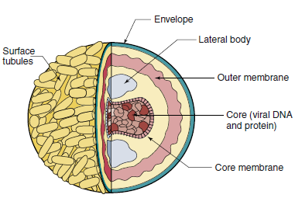

Replication of vaccinia virus. The core is released into the cytoplasm, where virion enzymes initiate transcription of early genes. A viral-encoded “uncoatase” enzyme then causes the release of DNA. Viral polymerase replicates the genome, and late transcription occurs. DNA and protein are assembled into cores within the core membrane. An outer membrane shrouds the core containing the lateral bodies and the enzymes required for infectivity. The virion is exocytosed or is released by cell lysis.
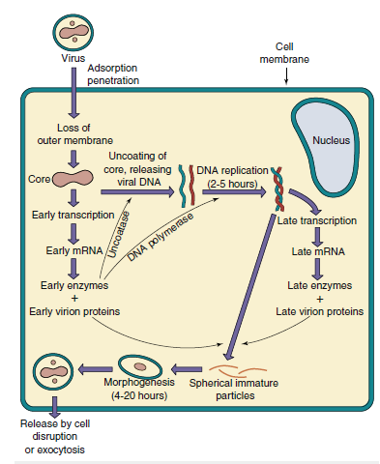

Disease Mechanisms of Poxvirus

Smallpox is initiated by respiratory tract infection and is spread mainly by the lymphatic system and cell-associated viremia.

Molluscum contagiosum and other poxviruses are transmitted by contact.
Virus may cause initial stimulation of cell growth and then cell lysis.
Virus encodes immune evasion mechanisms.
Cell-mediated immunity and humoral immunity are important for resolution.
Most poxviruses share antigenic determinants, allowing preparation of “safe” live vaccines from animal poxviruses.

Spread of smallpox within the body. The virus enters and replicates in the respiratory tract without causing symptoms. The virus infects macrophages, which enter the lymphatic system and carry the virus to regional lymph nodes. The virus then replicates and initiates a viremia, causing the infection to spread to the spleen, bone marrow, lymph nodes, liver, and all organs, followed by the skin (rash). A secondary viremia causes the development of additional lesions throughout the host, followed by death or recovery with or without sequelae. Recovery from smallpox was associated with prolonged immunity and lifelong protection.

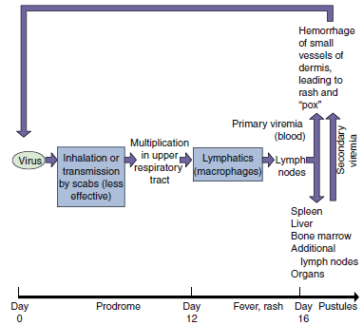

Properties of Natural Smallpox That Led to Its Eradication
Viral Characteristics
Exclusive human host range (no animal reservoirs or vectors)
Single serotype (immunization protected against all infections)
Shares antigenic determinants with other pox viruses.
Disease Characteristics
Consistent disease presentation with visible pustules (identification of sources of contagion allowed quarantine and vaccination of contacts)
Vaccine
Immunization with animal poxviruses protects against smallpox Stable, inexpensive, and easy-to-administer vaccine Presence of scar, indicating successful vaccination
Public Health Service
Successful worldwide World Health Organization program combining vaccination and quarantine

Diseases Associated with Poxviruses
